
ST ANDREW’S JUNIOR COLLEGE
Preliminary Examinations
Higher 2

Geography 9173/01
Paper 1 31 August 2026
INSERT 3 hours

READ THESE INSTRUCTIONS FIRST

This insert contains all the Resources referred to in the questions.

This document consists of 6 printed pages.

[Turn over

Resource 1 for Question 1

The global distribution of Apple’s suppliers by country in 2023
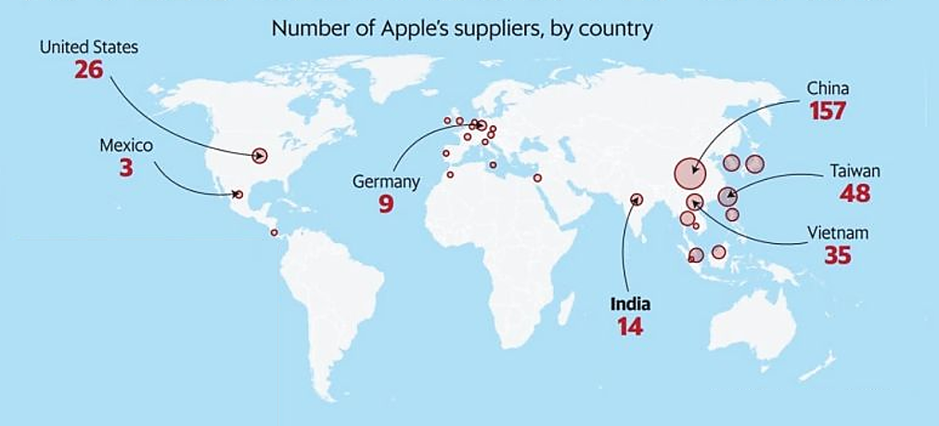

https://media.licdn.com/dms/image/v2/D4D22AQHtEusjU8yUXw/feedshare-shrink_800/B4DZcQHleDGcAg-/0/1748322114460?e=2147483647&v=beta&t=i7OVpTj0iOpzkqd-lhfrN24Yq6VZEBxxJGHCXqP8q5A

Resource 2 for Question 1

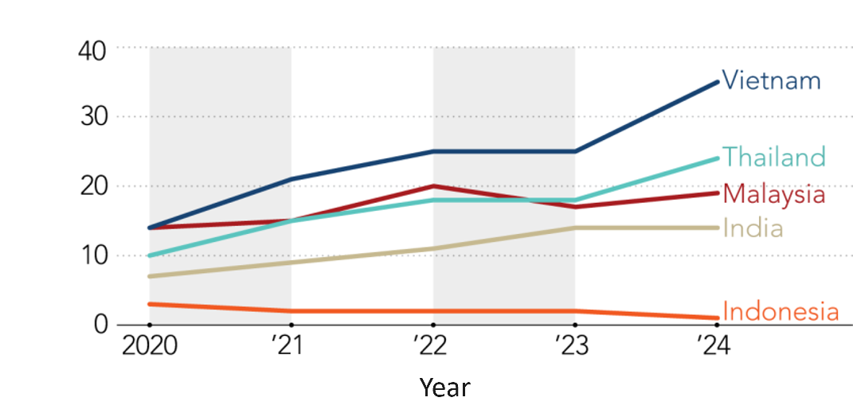
Number of Apple suppliers in Southeast Asia by country from 2020 to 2024
Number of suppliers

Resource 1 for Question 1

Resource 3 for Question 1
Operational structure of Apple’s global production network (GPN)

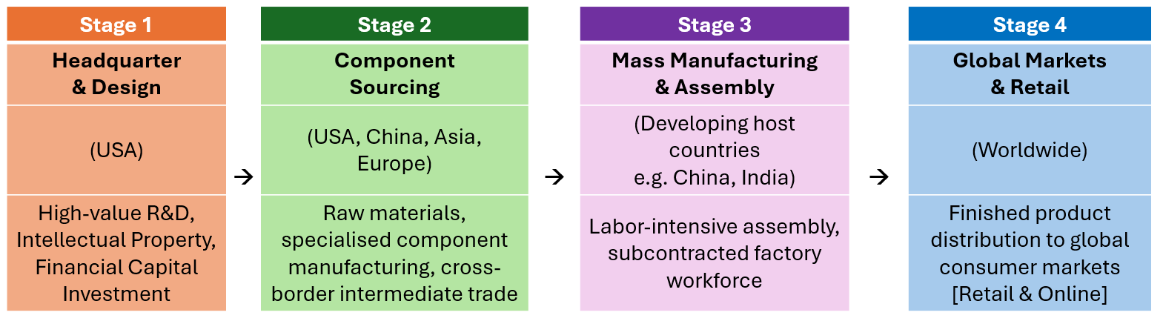

Resource 4 for Question 1
Excerpt on Apple’s GPN and host economies

While high-value research and development (R&D), design and software programming are concentrated at Apple’s headquarters in Cupertino, USA, physical manufacturing is outsourced heavily to developing economies. Assembly is largely outsourced to companies like Foxconn and Pegatron in China to exploit lower wage rates, cheaper land and vast manufacturing scale. Over 1 million people are involved in assembling, supplying and selling Apple products worldwide.

Operations in host countries have faced severe criticism over working conditions and labour practices. Workers at subcontractor facilities have reported excessive work hours (up to 60 hours per week, sometimes working 36 hours without a break) for low wages around $100 per month, alongside occupational health hazards such as chemical exposure during screen cleaning. Extreme stress and poor working conditions contributed to 14 employee suicides at a Foxconn facility in 2010, prompting the installation of safety nets on factory buildings.

Apple’s manufacturing distribution allows it to access global markets easily and bypass trade restrictions. However, supplier practices have faced environmental scrutiny, driving recent corporate commitments toward renewable energy and recycling initiatives across its supply chain.

[Turn over

Resource 5 for Question 2

Track and intensity of Super Typhoon Koppu from 13 to 20 October 2015

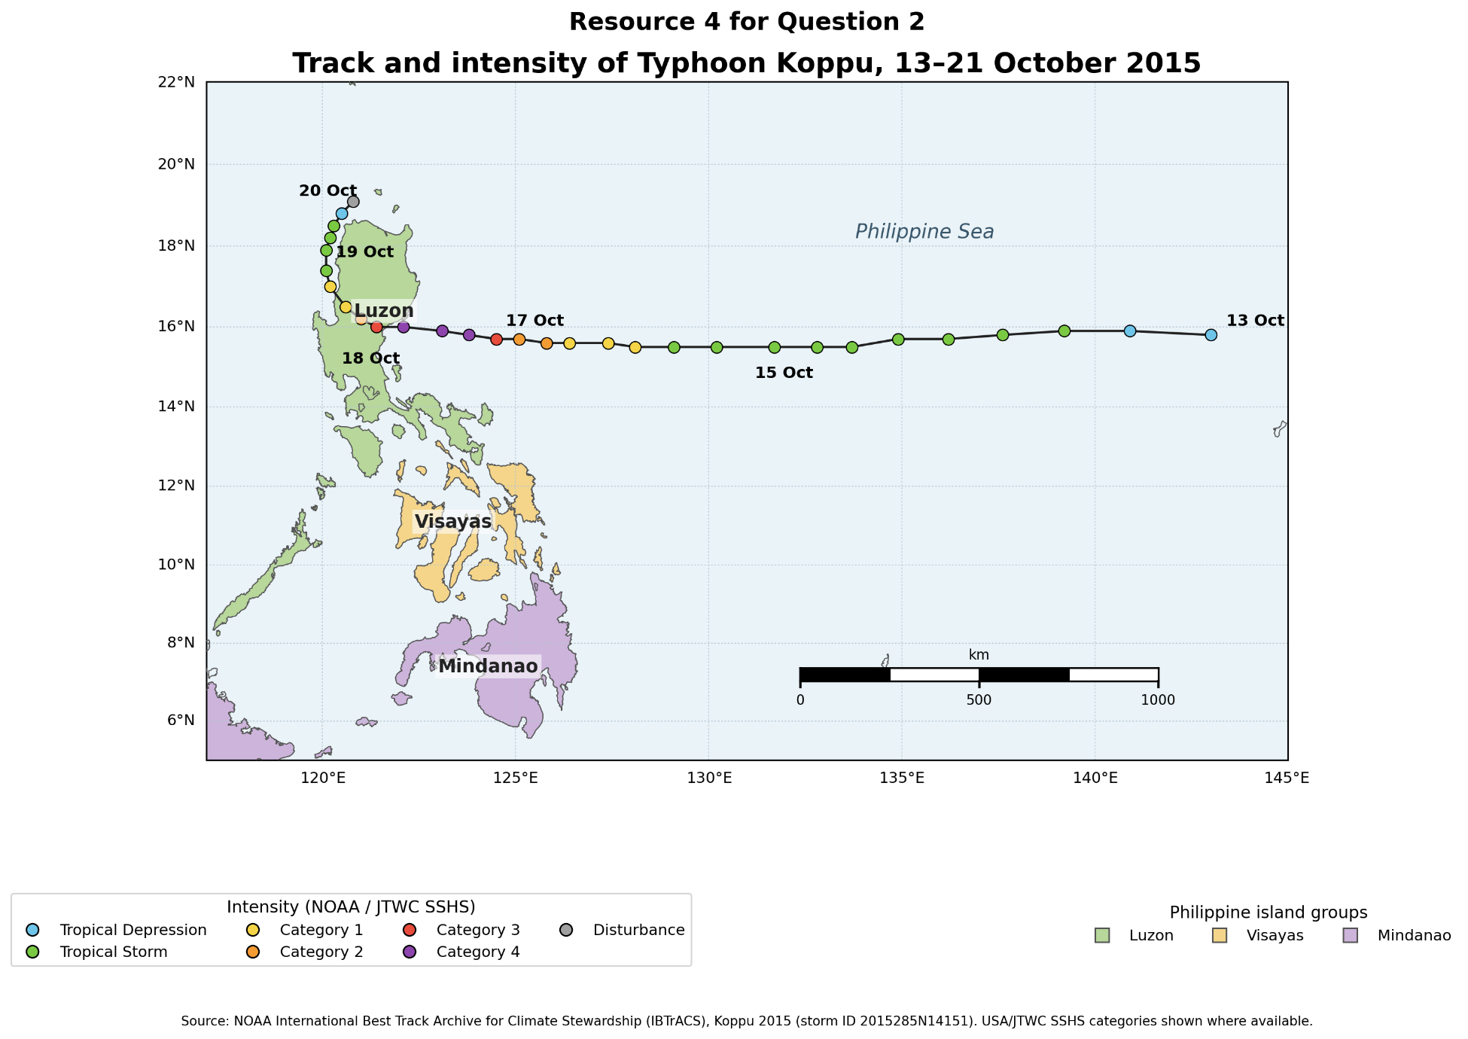

Resource 6 for Question 2

Changes in the estimated minimum central pressure and maximum surface wind speed of Koppu
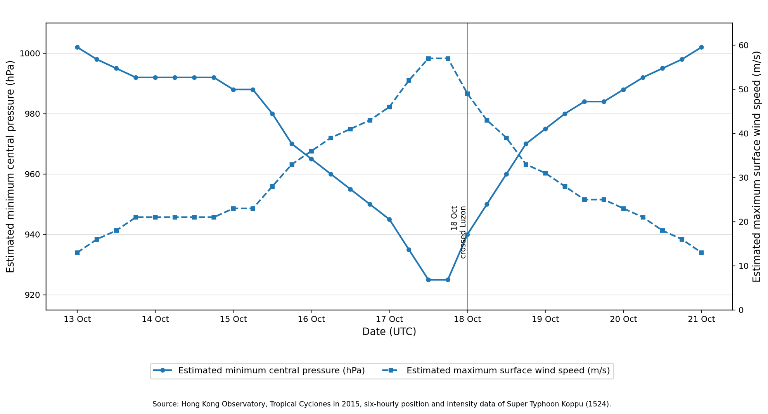
[Turn over
Resource 7 for Question 2

Typical sea surface temperatures and anomalies during the El Niño and La Niña conditions
